ONBOARD PROCESSING - NAVIGATION

UNAVCHK Marine Navigation Processing System (Western Geophysical)
Software Version | 1.9.6
Dedicated Computer | IBM Scaleable Power Parallel System (20 node SP2)

UNAVCHK, Western's navigation processing software, uses a sequential, extended Kalman filter to give an integrated network solution of the positions of all nodes within the marine network for every shotpoint. Special processing of some observations, e.g. slant ranges being reduced to the horizontal and cable compasses being reduced to chord azimuths, allows the mixing of compass and acoustic observations in a single integrated adjustment. Network nodes are positioned as a function of all the navigation observations, each observation being weighted by its standard deviation. Along the cables, a cubic spline interpolates the co-ordinates of the receivers as functions of along-cable distances of nodes and receivers. From each node on the gun strings, an estimate of centre of source position is obtained by simple layback and from these positions, a centre of source position is derived.

All computation is performed on the mapping plane. Compass bearings are corrected for magnetic declination and meridian convergence and geodetic azimuths are corrected for meridian convergence. Scale factor is applied to all ranges. The post-processing system provides comprehensive quality control tools including statistical reports, graphical displays and a variety of plots, such as time series plots, bullet plots and network node plots, all of which are used to confirm the accuracy and reliability of the Post Plot data. Comparisons of real-time to processed positions may also be performed.

Navigation Processing Flow Overview
- Reformat from P2/94 to UNAVCHK internal format.
- Select processing shotpoint range and create line database.
- Process sensor data.
- Network refinement.
- Source and Receiver co-ordinate computation.
- Output to P1/90 UKOOA.

At each stage in the processing flow, UNAVCHK provides extensive plots and statistical reports. These are used to perform comprehensive quality control analysis of all the navigation sensor measurements, and of the processing algorithms.

Navigation Sensor Processing
There are three essential processes that UNAVCHK can apply to the raw navigation data, in order to enhance the signal and attenuate noise before the network algorithm. The three filtering techniques are summarised below:

Manual Editing
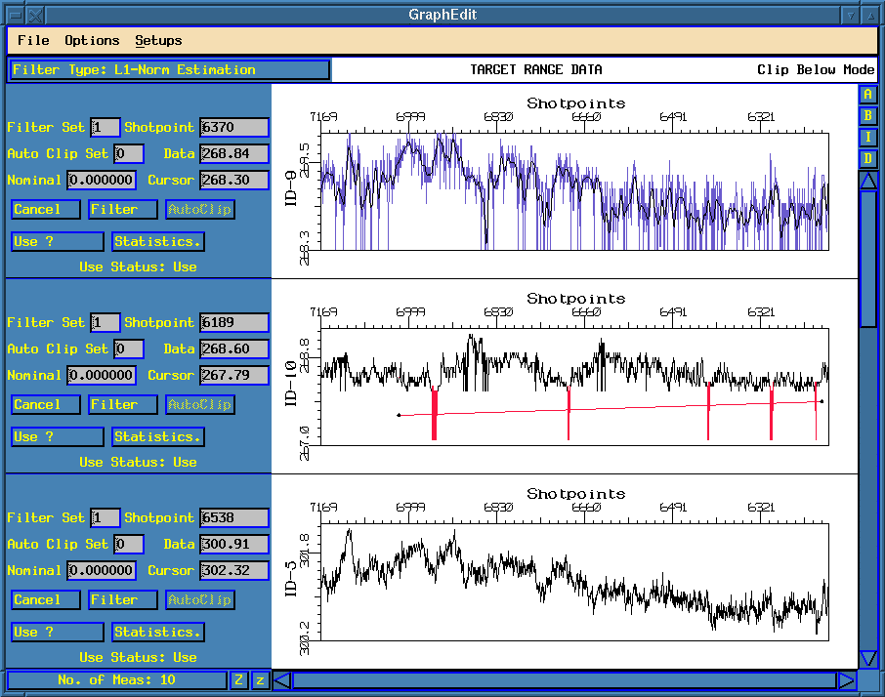
Figure 10.3-1 Senedt Graphical Editor
Manual editing allows the processor to replace outliers or spikes in the raw data with interpolated values. UNAVCHK’s Senedt provides a suite of tools that assist the processor in this task. The graphical editor (Figure 10.3-1) is particularly useful as it allows bad measurement ranges to be easily identified and selected for interpolation. UNAVCHK is able to use either linear or polynomial interpolation. The polynomial fit was used for this survey, due to its more accurate fit to the data.

Despiking
Despiking is an automatic filter designed to replace spikes or outliers with interpolated data. UNAVCHK uses a windowed median filter. A rolling window is centred on the shotpoint being filtered. If the data value for the shotpoint in question differs, by more than a threshold value, from the median of the values within the window, then the data value is replaced by an interpolated value.

Both the window length and the threshold are defined for each measurement by the processor. These filter parameters are usually determined at the start of the survey, from tests of the initial data, but may be changed on a line by line basis should the quality or character of the data change.

Smoothing
Smoothing attenuates random noise by applying a low pass filter. UNAVCHK uses a windowed, cosine-weighted average filter. A rolling window is centred on the shotpoint being filtered. The data value of the shotpoint being filtered is replaced by the weighted average of the data values within the window. The data values within the window are weighted by multiplying them with a truncated cosine function, which causes those data values closest to the shotpoint to be given more precedence.

Positioning Refinement Using Network Adjustment
The network refinement algorithm in Western's UNAVCHK post-processing system uses the sequential extended Kalman filter estimation technique. The extended Kalman filter generates optimal position co-ordinates by combining all the measurements available at a shotpoint, with the position co-ordinates at that shot, as predicted from earlier measurements. Measurements are weighted in the network according to their standard deviation. This standard deviation can be fixed for a particular measurement or measurement type, or can be dynamically computed by UNAVCHK for each shotpoint. During this survey dynamic SD computation was utilised for all sensors except for rGPS ranges and bearings, and compass ranges and bearings which straddle the last active section and the tail stretch on each streamer.

The main features of the network refinement algorithm are:
- Versatility in accommodating various measurements with the quality and reliability of each measurement handled appropriately by weighting.
- A fully integrated network solution for the full network achieved by using all available measurements, such as cable compass bearings, azimuths, acoustic ranges, absolute positions and relative geodetic observations.
- Data snooping technique based upon the innovation (measured minus predicted) values and W-statistics for detecting blunders or gross errors.
- Additional pseudo-measurements, such as physical and/or static distances, which are not directly measured by the real-time sensors, may be included to strengthen the network solution.
- The filter is recursive. The derived position co-ordinates are based on all the measurements up to the current shotpoint by carrying forward data from the previous shots in a fading memory filter.
- Computational efficiency through sequential processing of the measurements.
- Calculation of known biases such as cable stretch and cable rotation as part of the network solution.

Source and Receiver Co-ordinate Computations
After the completion of the network solution, the source and receiver co-ordinates are computed. This computation is based on the nodes that are on the sources and the cables. The source co-ordinate computation derives the geometric centre of a gun array, which comprises of several gun strings. Starting from a node with known co-ordinates derived from the network solution on a gun string, the offsets from the geometric centre of the gun-array and the calculated tow-angle are used to derive a solution for the geometric centre of the gun array. This computation is repeated for each node on a gun string. The source co-ordinates are then computed from the mean of the geometric centres derived from each gun string.

The receiver co-ordinates are derived by first fitting a cubic spline through the nodes on the cable. The co-ordinates of the cable nodes are derived from the network adjustment. The receiver co-ordinates are computed from the cable fit using the distance down the cable of each group. Cable stretch is computed as part of the network algorithm and the distance between each receiver group decreases from the head of the cable to the tail, reflecting the decrease in tension.

Quality Control Procedures
UNAVCHK provides an extensive set of plots and statistics, which are used to monitor the quality of the navigation data, and the accuracy of the processing algorithms. A few of the more important QC checks performed on a line-by-line basis are outlined below.

Data Quality Checks
- Shot time differences - following the creation of the UNAVCHK database, the time interval between shots is checked. Any spikes indicate either missing data, or anomalies with the vessel positioning.
- Raw, Processed and Raw Vs Processed Data - a number of plots and statistical reports are generated which provide detailed information about the quality of each measurement. A comparison between the raw and processed data highlights the quality of the processing and the suitability of the filter parameters.
- Sensor Vs Sensor comparisons - co-located sensors are compared against each other. Any differences will be due to errors within the data. Comparisons include vessel positions from primary and secondary navigation; headbuoy locations using laser ranging Vs rGPS; primary Vs secondary gyrocompasses and two-way acoustic ranges.

Network Refinement Quality Checks
- Network statistics - the computation of error and reliability statistics is an integral part of the network refinement algorithm. Statistics such as w-statistics, degrees of freedom, error ellipses, internal and external reliability, marginal detectable errors and χ² tests all contribute to the understanding of the quality of the network. All these statistics are produced as both time-series plots and statistical reports.
- Network residuals - time series plots of the residuals are produced for each measurement. The residual is the difference between the measured range and the range between the two nodes after network adjustment. Spikes or non-zero values indicate bad or biased measurements, or a problem with the network solution.
- Node movement - node movement anomalies indicate jumps in the network solution, which are usually caused by areas of weak geometry.
- Network solved biases - cable stretch and cable rotation, are both known biases which, are solved by the network algorithm. Stretch, caused by the towing tension on the cable, should be relatively constant, varying only with vessel speed, or during sharp manoeuvres. The stretch should decrease linearly from the head to the tail. Cable rotation is normally required to adjust the position of the tail end of the cable, as located using the cable compasses, to the position of the tailbuoy. The bias is mainly due to local fluctuations in the magnetic declination. It should remain relatively constant throughout the line and give a similar value for each cable.

Final Product Quality Checks
- Sail-line plot - the vessel, source, receiver and tailbuoy positions are taken from the P1/90 and plotted using a greatly exaggerated cross-line scale. This allows the comparative positions to be checked.
- Offset checks - the comparative positions of the vessel, sources, receivers and tailbuoys are also checked on the basis, of individual separations, both prior to output to P1/90 and again using the P1/90 positions. The comparisons from the P1/90 positions will be identical to those from the pre-P1 positions apart from changes caused by the loss of accuracy due to the P1/90 format, and the need to interpolate the non-firing source. However re-computing the offsets provides unambiguous confirmation of the P1/90 data quality. Each offset is also compared with the same offset from the other lines, allowing trends and anomalies to be identified.
- UNAVCHK Vs SPECTRA P1/90 Comparisons - the network algorithms used by UNAVCHK and SPECTRA follow two different routes to produce two final P1/90 datasets that are virtually independent of one another. Favourable comparisons between the two datasets give a high degree of confidence in the final data quality.
- P2/94 Header Differences - once the first set of P2/94 headers has been checked it can be used to compare against the set from the second line. The second line can then be used to compare with the third and so on. This quickly highlights any parameter changes within the P2/94, which can then be checked for validity.
- Statistical summaries - UNIX scripts are used to condense the statistical information from the line and flag deviations from a predetermined norm.

Navigation Data Deliverables
Navigation data was produced on the Western Pride in the formats listed below. All the navigation data produced was sent to Woodside Energy Ltd, with archive sets sent to both Western Geophysical, Perth and Western Geophysical, London.

Data shipment details can be found in Section 12 of this report.

Raw data format P2/94 UKOOA
Raw data was produced by Spectra in UKOOA P2/94 format. These datasets were checked for quality and amended if necessary before being shipped. Aside from some minor edits to improve the descriptive comments in the header cards, the final P2/94s were as recorded by the Spectra Navigation System.

Processed data format P1/90 UKOOA
Final post-processed navigation data was produced by UNAVCHK in UKOOA P1/90 format.
Several P1/90s were produced, each containing a different sub-set of the positioning data.

Source and Receiver P1/90 format.
The line name convention used was the same as the sail line name as used during acquisition.

Shot Records: W Western’s Extension Record
V Position of vessel NRP (main GPS antenna)
A Position of main GPS antenna
S Position of firing source
Z Positions of all sources, firing and non-firing
T Tailbuoy positions
E Echosounder position
Receiver Records: R Receiver positions

Water depths in these datasets were tidal adjusted to mean sea level using data supplied by Woodside Energy Ltd.

Vessel/Echosounder position P1/90 format
The line name convention used was the same as the sail line name as used during acquisition.

Shot Records: A Position of main GPS antenna
E Echosounder position

These datasets were created for bathymetric processing in WGC, London.

Bin Centre position P1/90 format
The line name convention used was similar to the sail line naming convention used during acquisition. The line was prefixed with W00INV, followed by a 4 digit number which corresponded to the cross-line cell number (CMP line) of the acquisition grid. The point number in columns 20-25 corresponded to the inline cell number (shotpoint number) of the acquisition grid

Shot Records: Q Position of the bin centre

The Q record was slightly modified to replace the water depth in columns 67-71 with the fold of coverage. Two P1/90s were produced, one using raw coverage, the other using flexed coverage.

Navigation Processing Comments

Data Quality
The navigation data was generally of good quality throughout the survey, with few problems seen. The adverse weather conditions seen on the prospect had the biggest impact on the quality of the navigation data. However, in all but the most extreme weather conditions the network had sufficient redundancy to produce valid node positions with estimated errors well within the contractual tolerances.
- Swell noise degraded the acoustics, especially the ranges from the gun-strings to the streamer heads.
- Increased noise was also apparent on the streamer compass data.
- Equipment damage due to heavy seas caused a number of sensor failures, mainly on the gun-strings and tailbuoys.
- High winds and seas caused steerng difficulties, which in turn lead to high node dynamics, most notably on sequences 112 (line 1846I5), 121 (line 1282P1) and 122 (line 1462P1).

Additional Processing Comments
- Sequences 001-004 were acquired with the seismic data from cables 5 and 6 assigned to incorrect channel sets, which gave the appearance of cables 5 and 6 being swapped. The P2/94 UKOOA files for these lines were manually edited to swap the streamer ID in the header, so that when the P1/90 UKOOA was produced the seismic data from these swapped cables were assigned the correct geometry.
- Depth processing was performed on the data from the compass/birds on each cable. The receiver depths were calculated from this data and these depths were written to the P1/90 UKOOA datasets.
- Raw echo sounder data was corrected for vessel draught of 5.94 m and for a velocity of sound calculated from the TS Dip data for the whole water column. Tidal corrections were also applied to adjust the water depths to Mean Sea Level, using tidal data supplied by Woodside.

